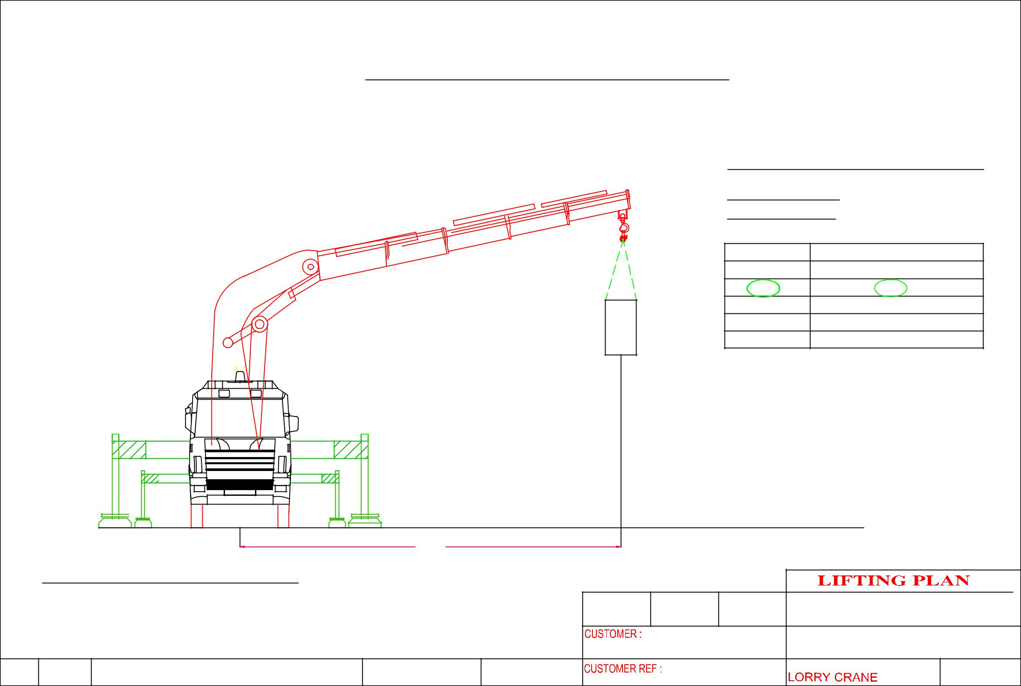
 |  |  | HOISTING OF MACHINE – BlK 5000 A.M.K Ave 5 #01-09 (ERATECH PTE LTD)
 |  |  |  |  |  |  |  | CRANE :PALFINGER PK100002E
 |  |  |  |  |  |  |  | LORRY CRANE
 |  |  |  |  |  |  |  | CRANE CONFIGURATI0N
 |  |  |  |  |  |  |  | OPERATING RADIUS : 5.6m
 |  |  |  |  |  |  |  | ^{OPT . RADIUS(m)} |  | LIFTING CAPACITY OF CRANE IN KG
 |  |  |  |  |  |  |  | 4.4 |  |  | 19,000
 |  |  |  |  |  |  |  | 5.6 |  |  | 14,800
 |  |  |  |  |  |  |  | 7.4 |  |  | 10,960
 |  |  |  |  |  |  |  | 9.2 |  |  | 8,630
 |  |  |  |  |  |  |  | 11.1 |  |  | 7,020
 |  |  |  |  | MACHINE WEIGHT | 9,970 KG |  | SAFETY FACTOR CALCULATION
 |  |  |  |  |  |  |  | WEIGHT OF MACHINE |  |  | : 9,970 KG
 |  |  |  |  |  |  |  | LIFTING ACCESSORIES WEIGHT : 100 KG
 |  |  |  |  |  |  |  | TOTAL WEIGHT OF LIFTING |  |  | :10,070KG
 |  |  |  |  |  |  |  | LIFTING CAPACITY |  |  | : 14,800KG
 |  |  |  |  |  |  |  | SAFETY FACTOR |  |  | : 1.469 KG
 |  |  |  | 5.6
 | CRANE :PALFINGER PK100002E
 |  |  |  |  |  |  |  |  | ERIC WONG MACHINERY TRANSPORTATION P/L
 |  |  |  |  |  |  | ERATECH Pte Ltd |  | DRAWING NAME:
 |  |  |  |  |  |  |  |  | HOISTING OF MACHINE

